Jimi Porter

Week 6 HW

09/27/2019

CIS 310-01

8.

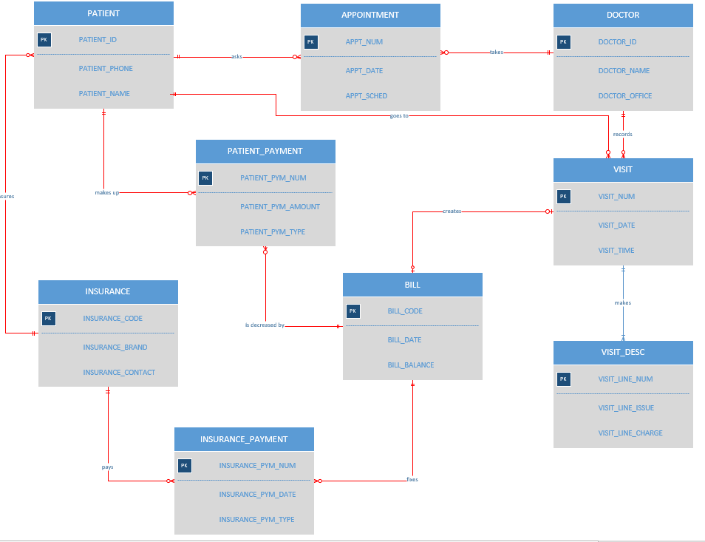

**\*\*Red Lines indicate weak relationships.\*\***

Autonomous Data Warehouse

The autonomous warehouse was designed with three characteristics in mind: easy, fast, and elastic. When it comes to easy it contains two components: automated management and automated tuning. When it comes to fast, it relates to being based on Exadata technology. Finally, when it concerns elasticity, it means instant scaling of compute or storage with no downtime. These three characteristics together really build a new experience when it comes to a data warehouse.

Getting started with autonomous data warehouse requires only a few inputs. First, when it comes to provisioning it requires four questions: Database name, Number of CPU’s, Number of terabytes, and the administrator password. A new service is created in seconds regardless of the size. Oracle autonomous data warehouse is making optimal decisions for how to configure or make up and manage systems. When we are talking about autonomous data warehouse, it means managing itself. This automated management consists of end-to-end management of the data warehouse, which leads to: Provisioning new database instances, - growing/shrinking of storage or computation, patching and upgrades, and finally backup and restore. The full lifecycle is then managed using service console or API’s. As a customer, you don’t need to worry about managing a database.

The autonomous data warehouse also provides automated tuning, which displays the concept of “load and go”, where you define the tables, load data, and then run queries. No tuning is required, and no special database expertise is needed. This automated tuning also includes simple web-based monitoring console and built-in resource management plans. The autonomous data warehouse also has automated reliability which means it is fault tolerant and a highly available Exadata infrastructure. It also consists of automatic backups and online patches which is applied with zero downtime. This autonomous data warehouse also allows for easy migration from other systems, like existing Oracle systems, AWS Redshift systems, and more.